**<https://www.kdll.org/local-news/2024-11-15/kpbsd-considers-stricter-cell-phone-policies-after-state-guidance> 12.5.2024**

[**Local News**](https://www.kdll.org/local-news)

**KPBSD considers stricter cell phone policies after state guidance**

**KDLL | By**[**Ashlyn O'Hara**](https://www.kdll.org/people/ashlyn-ohara)

Published November 15, 2024 at 6:00 PM AKST

* [Facebook](https://www.facebook.com/dialog/share?app_id=354443369878053&display=popup&href=https%3A%2F%2Fwww.kdll.org%2Flocal-news%2F2024-11-15%2Fkpbsd-considers-stricter-cell-phone-policies-after-state-guidance)
* [Twitter](https://twitter.com/intent/tweet?url=https%3A%2F%2Fwww.kdll.org%2Flocal-news%2F2024-11-15%2Fkpbsd-considers-stricter-cell-phone-policies-after-state-guidance&text=KPBSD%20considers%20stricter%20cell%20phone%20policies%20after%20state%20guidance)
* [LinkedIn](https://www.linkedin.com/shareArticle?url=https%3A%2F%2Fwww.kdll.org%2Flocal-news%2F2024-11-15%2Fkpbsd-considers-stricter-cell-phone-policies-after-state-guidance&mini=true&title=KPBSD%20considers%20stricter%20cell%20phone%20policies%20after%20state%20guidance&summary=The%20current%20landscape%20of%20school%20cell%20phone%20policies%20in%20Alaska%20is%20inconsistent%20%E2%80%93%20there%20are%20no%20statewide%20rules.%20And%20on%20the%20Kenai%20Peninsula%2C%20the%20policies%20can%20vary%20from%20school%20to%20school%20and%2C%20sometimes%2C%20from%20classroom%20to%20classroom.&source=KDLL)
* [Email](mailto:?body=KPBSD%20considers%20stricter%20cell%20phone%20policies%20after%20state%20guidance%0A%0Ahttps%3A%2F%2Fwww.kdll.org%2Flocal-news%2F2024-11-15%2Fkpbsd-considers-stricter-cell-phone-policies-after-state-guidance%0A%0AThe%20current%20landscape%20of%20school%20cell%20phone%20policies%20in%20Alaska%20is%20inconsistent%20%E2%80%93%20there%20are%20no%20statewide%20rules.%20And%20on%20the%20Kenai%20Peninsula%2C%20the%20policies%20can%20vary%20from%20school%20to%20school%20and%2C%20sometimes%2C%20from%20classroom%20to%20classroom.)

Listen • 3:46

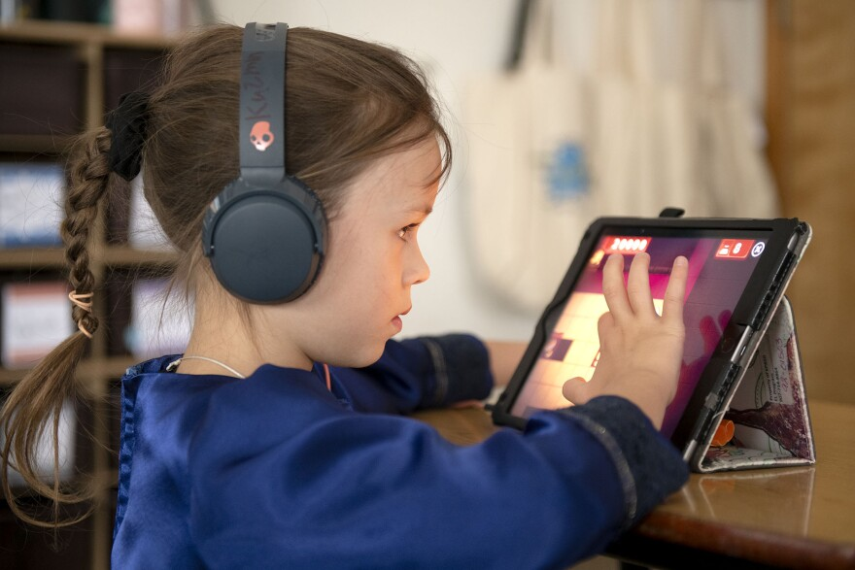

*M.Scott Moon*

*/*

*KDLL*

Anastasia Kuzmin uses a tablet computer to work on a personalized instruction plan in a classroom at Voznesenka School.

What’s the best way to limit student cell phone use and distractions in schools? Locking pouches? All-out bans for kids in certain grades? After state education officials issued a call for more restrictive policies, the Kenai Peninsula Borough School District is working through these questions.

The district’s existing cell phone policy was enacted in 2013. It’s enforced by school principals and staff and covers *all* personal electronic devices, including laptops and tablets. The policy says the devices can’t be used during instruction time without teacher approval, during school activities or when otherwise not allowed by the school.

The current landscape of school cell phone policies in Alaska is inconsistent – there are no statewide rules. And on the Kenai Peninsula, the policies can vary from school to school and, sometimes, from classroom to classroom.

District Superintendent Clayton Holland told school board members last week they’ve underscored the policy’s importance in recent school years.

“Until we re-emphasized this policy starting last year and then again, at the beginning of this year with a hard push, it was pretty common that kids were having them out,” he said.

But now, they’re considering more restrictions.

That’s after the *state* board of education called on Alaska’s education department last month [to limit cell phone use during school hours](https://alaskabeacon.com/2024/10/24/alaska-joins-growing-number-of-states-considering-crackdown-on-cellphones-in-schools/). In a resolution, the state board urged school districts to implement new policies and asked school staff to take on supervisory roles.

If a statewide policy is implemented, Alaska would join [a growing number of states](https://www.npr.org/2024/08/29/nx-s1-5093778/as-more-schools-ban-cell-phones-this-is-how-its-working-at-one-colorado-school) moving to restrict cell phone use in schools. In some states, those restrictions look like [an outright ban](https://www.npr.org/2024/09/10/nx-s1-5105976/indiana-school-cellphone-ban-students-teachers). In others, students [lock their phones in magnetic pouches](https://www.npr.org/2024/08/29/nx-s1-5093778/as-more-schools-ban-cell-phones-this-is-how-its-working-at-one-colorado-school) for part or all of the school day.

On the Kenai Peninsula, some of the district’s 42 schools have more restrictive cell phone policies than others.

For example, Nikiski Middle/High School implemented new restrictions this school year. Middle school students are required to put their phones in their lockers during the school day. High school students are allowed to have their phones, but must put them in a designated spot when entering a classroom or the school library. Homer High School’s [got similar rules](https://www.homernews.com/news/homer-high-school-outlines-enforcement-policy-for-cellphone-use/).

On the southern peninsula, Homer Flex High School is [trying out those magnetic pouches](https://kpbsd.org/schools/homer-flex/wp-content/uploads/sites/7/2024/08/Homer-Flex-Handbook-2024-2025.pdf). They’re made by a company called Yondr. Students can keep their phones on them all day, but can only take them out of the pouch by unlocking them with magnets at designated spaces.

A Pew Research study of more than 5,100 Americans in September and October found [most – 68% – support a ban](https://www.pewresearch.org/short-reads/2024/10/14/most-americans-back-cellphone-bans-during-class-but-fewer-support-all-day-restrictions/) on cell phone use during class time for middle and high school students. A separate Pew Research study of public high school teachers in 2023 found that most – 72% – said cell phone distractions [are a problem in their classrooms](https://www.pewresearch.org/social-trends/2024/04/04/challenges-in-the-classroom/).

During last week’s work session, the board was in general agreement that cell phone use disrupts student learning. Board member Sarah Douthit demonstrated.

“I'm in the thick of this because I have two kids in high school, and I just texted one of them, who's in science, and he responded,” she said.

Emerson Kapp is the board’s student representative. She’s a senior at Soldotna High School and says teachers are just as bad about using cell phones at school. She says the district’s existing policy isn’t uniformly enforced and any changes implicate *other* devices, like personal computers and smart watches.

“Some teachers are very lenient on the policy and allow us to have our phones out, and other teachers are not,” she said. “So if we change the policy, who’s to say that those teachers won’t just keep not caring about it.”

Multiple board members and district staff said they’re reluctant to put teachers on the hook for enforcing stricter policies. Jason Tauriainen says that’s part of why he supports strict limits.

“You cannot monitor 20-plus kids in a classroom at all times and know what they have, when all they have to do is swipe over from one screen to the other,” he said. “And that's all it takes to go from Pornhub to my report on Martin Luther King Jr.”

Board member Kelley Cizek says schools are preparing students to succeed in life after school. And in the real world, she says people use cell phones.

“How draconian do we want to be?” she said. “Because I think at high school, part of it should be helping them to figure out how to operate in the real world. I mean, we're about to send them into, you know, into an adult environment.”

The board’s discussion was just that – a discussion. Any proposed changes to district wide rules would first go to the district’s policy committee, then on to the full school board for a vote up or down. [The current policy](https://go.boarddocs.com/ak/kpbsd/Board.nsf/goto?open&id=BE4URU7D5D9A) is on the board’s BoardDocs site.

Reporting in Soldotna, I’m Ashlyn O’Hara.

**Tags**

[Local News](https://www.kdll.org/local-news) [Kenai Peninsula News](https://www.kdll.org/tags/kenai-peninsula-news)[Kenai Peninsula Borough School District](https://www.kdll.org/tags/kenai-peninsula-borough-school-district)[Kenai Peninsula Borough School District Board of Education](https://www.kdll.org/tags/kenai-peninsula-borough-school-district-board-of-education)

* [Facebook](https://www.facebook.com/dialog/share?app_id=354443369878053&display=popup&href=https%3A%2F%2Fwww.kdll.org%2Flocal-news%2F2024-11-15%2Fkpbsd-considers-stricter-cell-phone-policies-after-state-guidance)
* [Twitter](https://twitter.com/intent/tweet?url=https%3A%2F%2Fwww.kdll.org%2Flocal-news%2F2024-11-15%2Fkpbsd-considers-stricter-cell-phone-policies-after-state-guidance&text=KPBSD%20considers%20stricter%20cell%20phone%20policies%20after%20state%20guidance)
* [LinkedIn](https://www.linkedin.com/shareArticle?url=https%3A%2F%2Fwww.kdll.org%2Flocal-news%2F2024-11-15%2Fkpbsd-considers-stricter-cell-phone-policies-after-state-guidance&mini=true&title=KPBSD%20considers%20stricter%20cell%20phone%20policies%20after%20state%20guidance&summary=The%20current%20landscape%20of%20school%20cell%20phone%20policies%20in%20Alaska%20is%20inconsistent%20%E2%80%93%20there%20are%20no%20statewide%20rules.%20And%20on%20the%20Kenai%20Peninsula%2C%20the%20policies%20can%20vary%20from%20school%20to%20school%20and%2C%20sometimes%2C%20from%20classroom%20to%20classroom.&source=KDLL)
* [Email](mailto:?body=KPBSD%20considers%20stricter%20cell%20phone%20policies%20after%20state%20guidance%0A%0Ahttps%3A%2F%2Fwww.kdll.org%2Flocal-news%2F2024-11-15%2Fkpbsd-considers-stricter-cell-phone-policies-after-state-guidance%0A%0AThe%20current%20landscape%20of%20school%20cell%20phone%20policies%20in%20Alaska%20is%20inconsistent%20%E2%80%93%20there%20are%20no%20statewide%20rules.%20And%20on%20the%20Kenai%20Peninsula%2C%20the%20policies%20can%20vary%20from%20school%20to%20school%20and%2C%20sometimes%2C%20from%20classroom%20to%20classroom.)

](https://www.kdll.org/people/ashlyn-ohara)

[**Ashlyn O'Hara**](https://www.kdll.org/people/ashlyn-ohara)

Prior to joining KDLL's news team in May 2024, O'Hara spent nearly four years reporting for the Peninsula Clarion in Kenai. Before that, she was a freelance reporter for The New York Times, a statehouse reporter for the Columbia Missourian and a graduate of the University of Missouri School of Journalism. You can reach her at aohara@kdll.org

[See stories by Ashlyn O'Hara](https://www.kdll.org/people/ashlyn-ohara)