Production Team & Crew Students & Staff of KTN Spring Break Theater Workshop

Co-Director ---------------------------- Torah Zamora PRESENT

Co-Director ----------------------------- Jack Finnegan “Origin of Sun, Moon, and Fog”

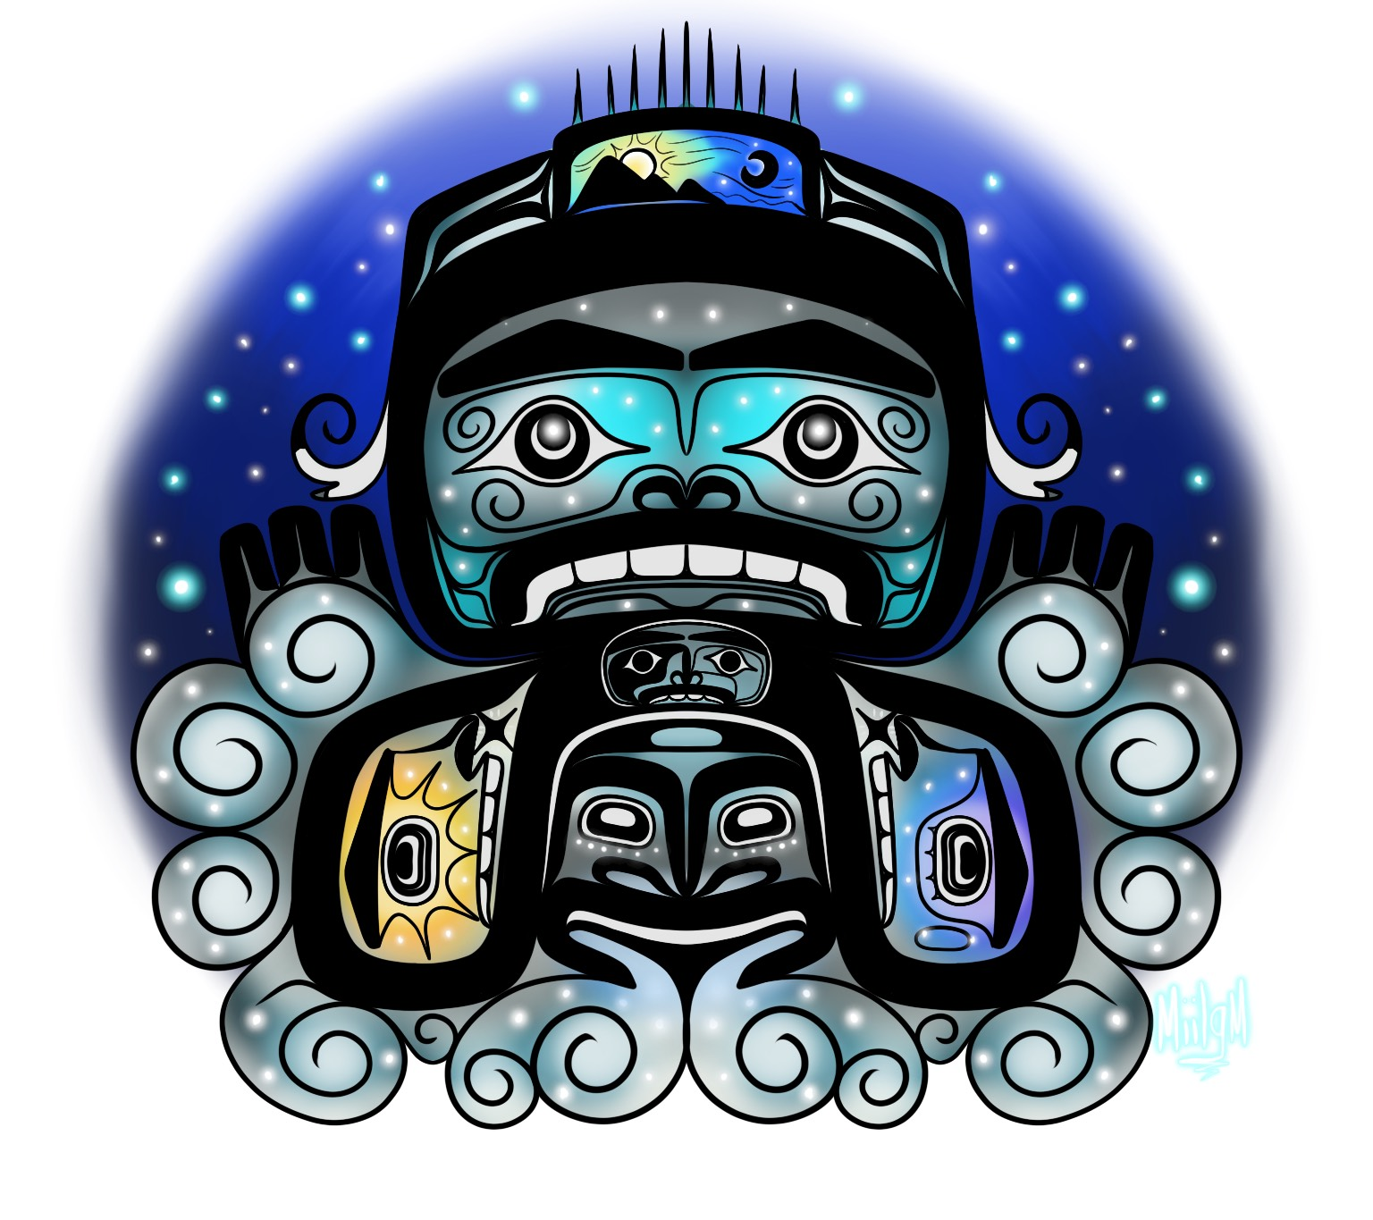

Teaching Artist/Props Designer ------ Miilgm Ts’amtii

L’eeneidi ------------------------------------ Yeil Atoowu

SHI Liaison ----------------------------- Nancy Barnes

made possible through the collaboration of

GUNALCHEESH Sealaska Heritage Institute

HAW’AA First City Players

N’TOYSUT NUUSM U.S. Forest Service - Southeast Discovery Center

CAST ARTIST

Narrator 1 -------------------------------------- Dominic Blair Props/Masks/Costumes by: Miilgm Ts’amtii, Yeił

Narrator 2 -------------------------------------- Emma Tyson Atoowu, Meghan Baumgartner, Dominic Blair, Aubree

Narrator 3 ----------------------------------- Felicia Hudson Booth, Regan Brown, Gabriel Cisneros, Mason Crowley,

Narrator 4 ------------------------------------ Aubree Booth Landyn Finger, Kevin Willard Flanery, Aurora Hopps,

Hannah Haponski, Avery Haponski, Felicia Hudson,

Desmond Krum, Jonah Long, Michael Milne-DeWitt, Chief-of-the-Sky ---------------------Michael Milne-DeWitt Cam Milton, Layla Orr, “Hunter” Edward Rodgers, Sun/The-One-Who-Walks-All-Over-The-Sky ------ Cam Milton BellaLynn Tucker, Emma Tyson, and Bella Weber.

Moon/Walk-About-Early ---------------------- Landyn Finger

Fog/Support-Of-Sun ---------------------- BellaLynn Tucker additional contributions and support from:

Village Servant -------------------------------- Aurora Hopps Yaakdushi for regalia, Halli Keynoyer for costume/props,

Council Member 1 ---------------------------- Desmond Krum Keith Smith for materials, parents/guardians for all

Council Member 2 --------------------- Meghan Baumgartner round support and signing up our awesome performers

Tribal Members ------------ Regan Brown, Hannah Haponski

Porcupine ------------------------------------ Gabriel Cisneros

Dog Council --- Mason Crowley, Avery Haponski, Jonah Long ADAAWX

Villager Ensemble/Animal Council -- Meghan Baumgartner,

Regan Brown, Gabriel Cisneros, Mason Crowley, Aurora “The Origin of Sun, Moon, and Fog” script is an

Hopps, Hannah Haponski, Avery Haponski, Desmond Krum, adaptation by Torah Zamora of the adaawx found in Jonah Long, Layla Orr, Bella Weber an old government book (the 31st Annual Report of the Bureau of Ethnology - “Tsimshian Myth”) This

MUSIC original adaawx was recorded by Henry Tate, a

“Miilgm Chant” gifted by Miilgm Ts’amtii Tsimshian man who worked with Tsimshian elders

Drummers: Regan Brown, Bella Weber to record our stories so we can know them now.